**ME 752 Optimization Theory: Algorithm Study**

**Name – Vasu Bansal**

**Roll Number – 160776**

**Algorithms Studied –** Cauchy’s Steepest Descent Method, Nelder Mead’s Simplex search and Powell’s Conjugate Direction Method.

**Test Functions used –**

${\left(x^{2}+y-11\right)}^{2}+{\left(x+y^{2}-7\right)}^{2}$

$20-20e^{-0.2\sqrt{0.5\left(x^{2}+y^{2}\right)}}+e^{0.5(cos\left(2πx\right)+\cos\left(2πy\right))}$

${\left(x-2\right)}^{2}+{\left(x-2y\right)}^{2}$

$-2sin\left(x\right)+0.1y^{2}$

$-(2xy+2x-x^{2}-2y^{2})$

$sin^{2}\left(3πx\right)+{\left(x-1\right)}^{2}(1+sin^{2}\left(3πy\right)+{\left(y-1\right)}^{2}(1+sin^{2}(2πy))$

${\left(x^{2}-y\right)}^{2}+{\left(1-x\right)}^{2}$

$-0.26\left(x^{2}+y^{2}\right)-0.48xy$

In this study, the algorithms were coded entirely in Python. I have used libraries like numpy for matrix manipulation, time for calculating elapsed time, matplotlib for plotting and scipy for implementing Golden Section search.

As Python does not offer direct computation of gradient, the gradient had to be manually coded. So, for simplicity I have used 2 variable problems in the study. However, the code will work for n-dimensional function provided that functions are implemented to return the function value and gradient vector.

${\left(x^{2}+y-11\right)}^{2}+{\left(x+y^{2}-7\right)}^{2}$

1. **Nelder Mead**

Black point indicates initial point. Red point indicates final point.

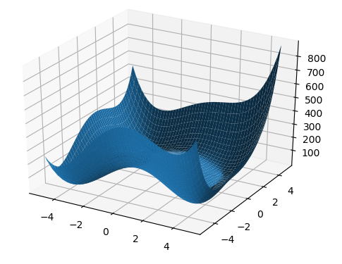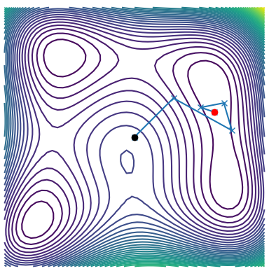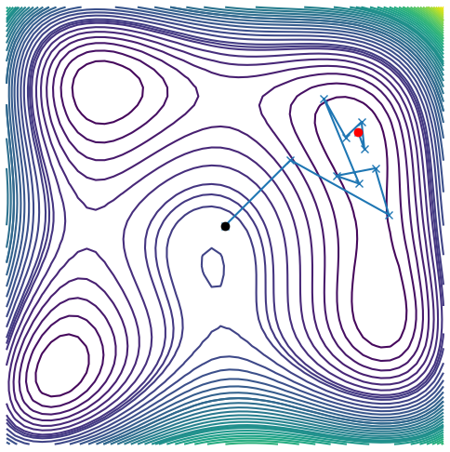

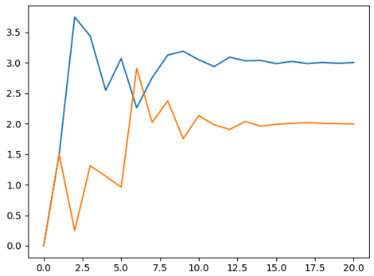 This is the plot of x and y values at successive iterations. We can see that algorithm converges after 15 iterations. Also, initially there is a spiky nature observed. Elapsed time for 20 iterations is 0.0403 seconds.

1. **Cauchy’s steepest descent method**

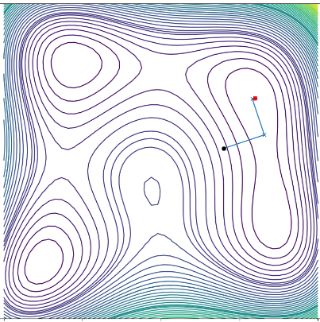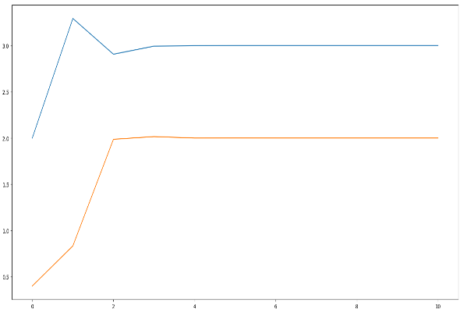We can see that the convergence takes only 2 steps.

1. **Powell’s conjugate direction method**

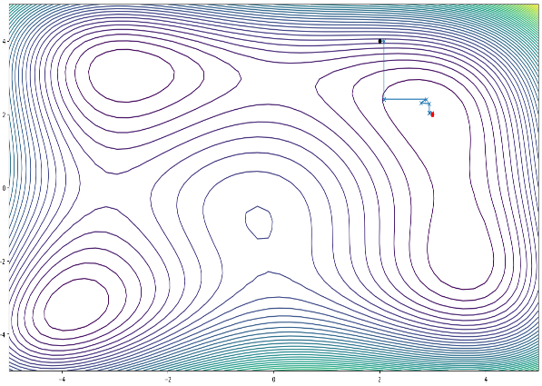

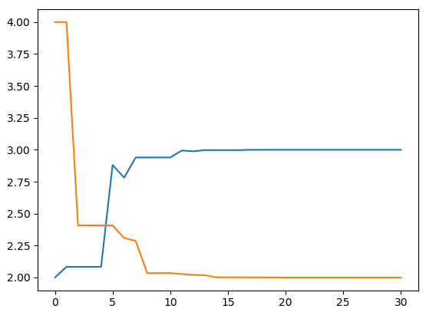The algorithm converges after ~8 iterations. We can see that there is no spiky behavior like that in Nelder Mead method.

$20-20e^{-0.2\sqrt{0.5\left(x^{2}+y^{2}\right)}}+e^{0.5(cos\left(2πx\right)+\cos\left(2πy\right))}$

1. **Nelder Mead Algorithm**

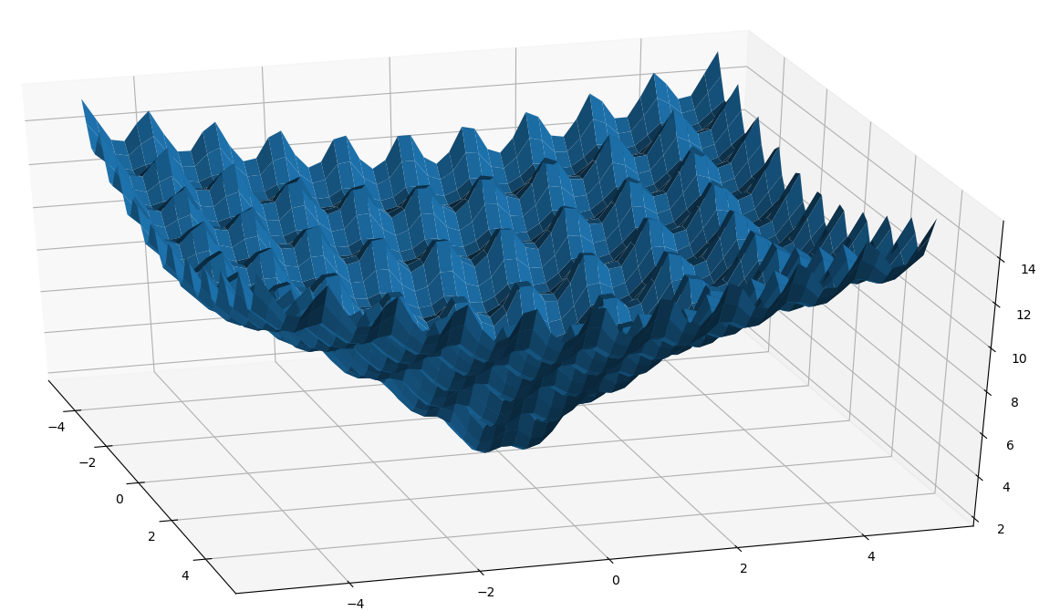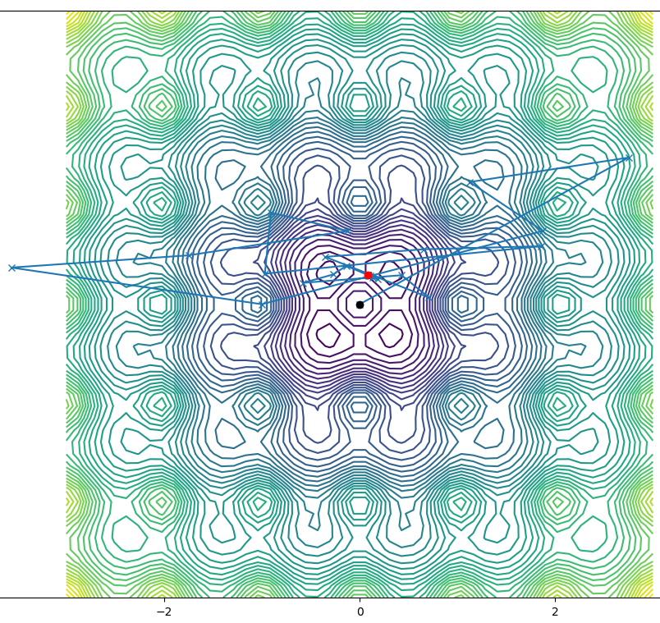

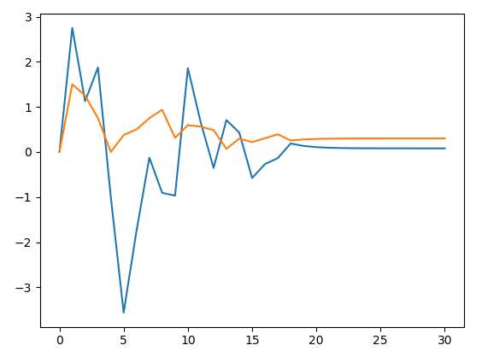

**2. Cauchy’s Steepest Descent Method**

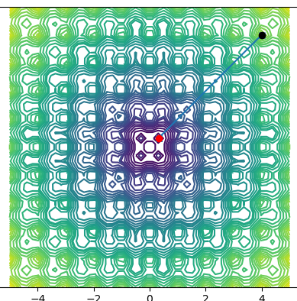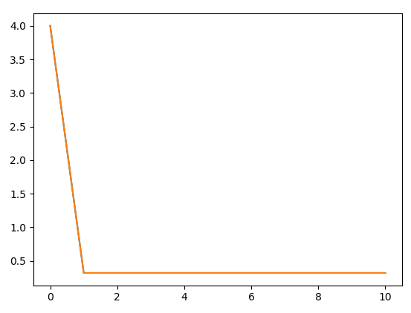

**3. Powell’s Conjugate Direction Method**

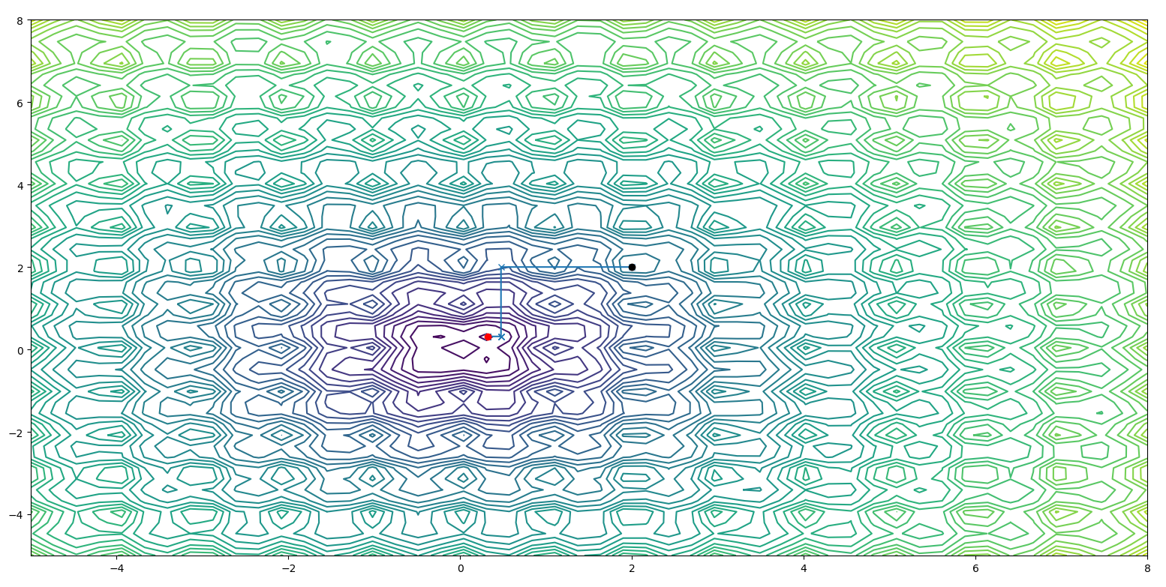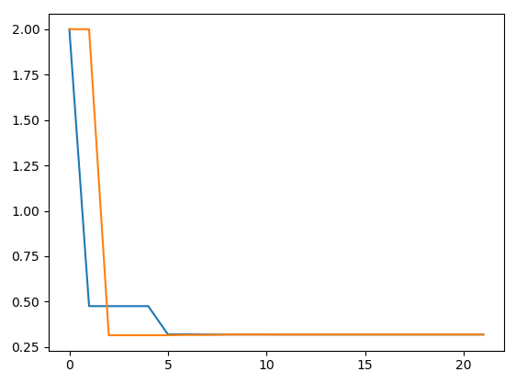

3.

1. **Nelder Mead Algorithm**

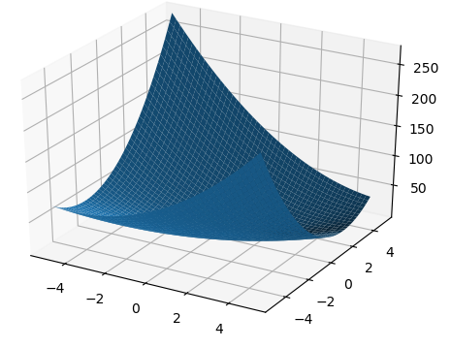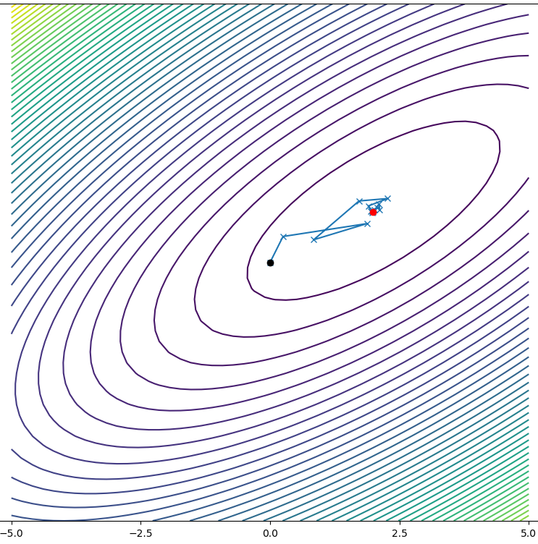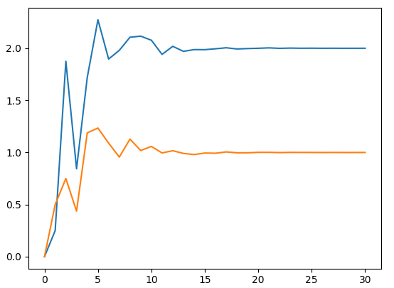

**2. Cauchy Method**

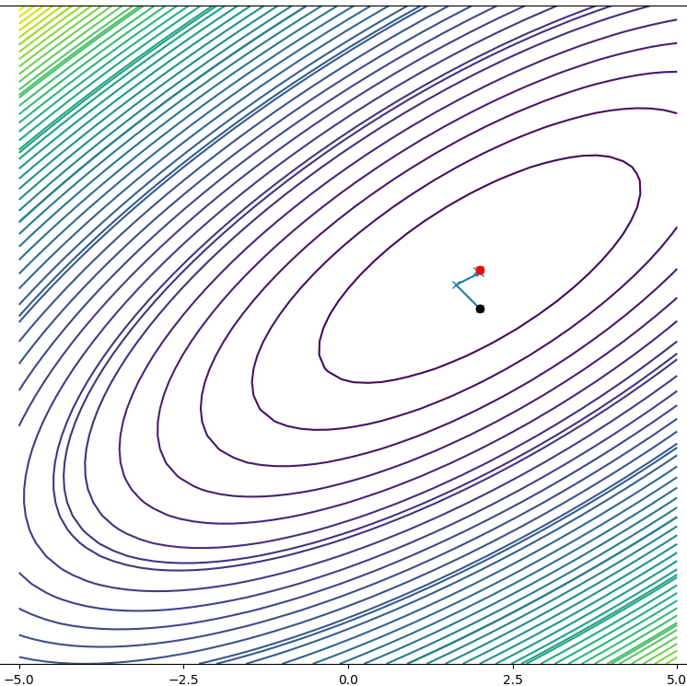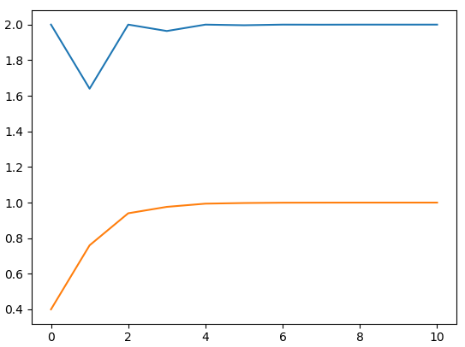

**3. Powell’s conjugate direction**

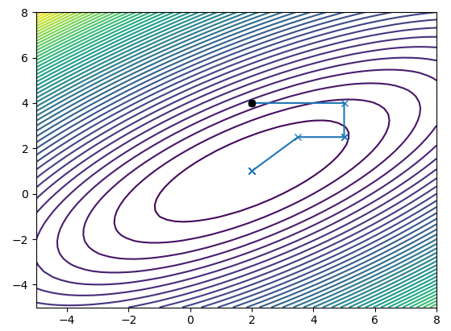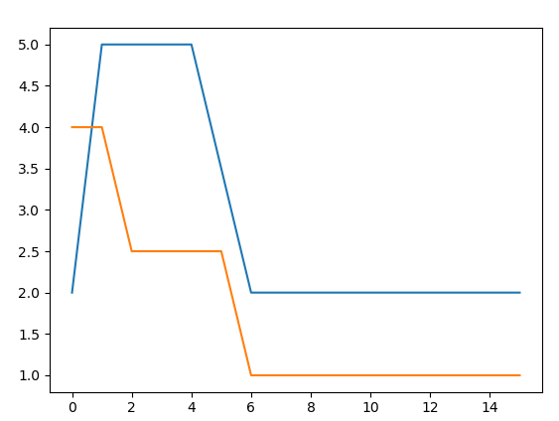

**Observations and Conclusions**

1. Cauchy’s steepest descent method is a gradient based method whereas Nelder Mead and Powell’s Conjugate Direction method are gradient free methods.

2. Gradient calculation is computationally expensive. Thus for complicated functions like function no. 2 and 6 it should be avoided. It is also very prone to get stuck in local optima. However it’s convergence is very fast.

3. Nelder Mead is less susceptible to get stuck however in initial iterations it shows very irregular and spiky behavior. That is, the function increases then decreases then again increases. It’s convergence rate is also not very good.

4. Powell’s conjugate direction method does not show irregular and spiky behavior like Nelder Mead’s. Also it’s convergence is very good compared to it.

Cauchy’s method should be used for initial few iterations so as to get closer to an optimum. After that Powell’s Conjugate direction method can be used further for accuracy.